OPM - SCRD Windows Integrated Security - PoC Assembly v1.0
Deployment Guide

Revision History
Author | Revision Number | Date
TCSASSEMBLER | 1.0 | 09/19/2013

1. Organization of Submission 3
2. Application Setup 3
2.1 build.properties File 3
2.2 Build Scripts Setup 3
2.3 Environment: 3
3. Setup Instruction 3
4. AD Server Setup 4
4.1 install DNS Service 4
4.2 Install Active Directory 5
4.3 Create Groups 5
4.4 Create Domain User 6
4.5 Configure Kerberos Service Principal (keytab) 6
5. JBOSS Server Setup 7
5.1 Install softwares 7
5.2 Configure static ip and host name 7
5.3 Configure Kerberos Client 8
5.4 Install JDK6 9
5.5 Install and Configure JBOSS 9
5.6 Install Ant 10
6. Windows Client Setup 10
6.1 Configure static ip 10
6.2 Join Domain 11
6.3 Configure host for JBOSS Server 14
6.4 Configure IE 15
6.5 Configure Firefox 15
6.6 Configure Chrome 16
7. Deployment Instructions 16
8. Verification 16
8.1 Browser Configuration verification 16
8.2 Security Domain verification 17
8.3 Test page verification 18
8.4 Verify Cache 19
8.5 Possible issues 19
9. Resource Contact List 20

Deployment Instructions

Organization of Submission

The content of submission follows directory structure provided below:

conf – contains the configuration files for the application
docs – contains the deployment guide (this document)
src/java/main – contains the classes for this assembly
src/sql – contains the schema definition and utility sql files used
test_files- contains the jboss configuration files and etc used during verification
build.xml –the Ant build file.
build.properties – the build properties file

Application Setup

build.properties File
build.properties, the properties introduced in this assembly.

Property Name | Description
jboss_home | jboss home directory
war.dist.name | war file name

Build Scripts Setup
- clean – cleans the build
- compile – compiles all the java files
- war - package all sources as war
- deploy- deploy war to jboss

Environment:
Java 1.6 http://www.oracle.com/technetwork/java/javasebusiness/downloads/java-archive-downloads-javase6-419409.html#jdk-6u45-oth-JPR(You can not use openJDK)
J2EE 1.6
Ant 1.8+
JPA2
Hibernate 4.2.3: http://www.hibernate.org/
PostgreSQL 9.2.4: http://www.postgresql.org/(use H2 database in this poc assembly)
RedHat Enterprise Linux Server 6.4: http://www.redhat.com/products/enterprise-linux/server/(use Centos 6.4 instead in this poc assembly)
JBoss Enterprise Application Platform 6.1: http://www.redhat.com/products/jbossenterprisemiddleware/application-platform/
Windows Server 2008 R2 SP1
Active Directory
VMware or VirtualBox

Setup Instruction
There will be totally three computers to verify,I list OS and important softwares in below tables
I will use
AD Server to represent the computer that install active directory
JBOSS Server to represent the computer that install JBOSS eap 6.1
Windows Client to represent the computer that verify page
if you test page directly in AD Server it will not work because it will use NTLM not Kerberos/SPNEGO
so you should prepare at least three computer to verify this assembly
1
AD Server
OS | windows Server 2008 R2 SP1
Software | DNS Service,Active Directory
ip | 192.168.11.162
dns | 192.168.11.162
hostname | WIN-JCQFIBC8D2I.tctest.com
2
JBOSS Server
OS | Centos 6.4
Software | Oracle JDK 1.6,JBOSS EAP 6.1
ip | 192.168.11.18
dns | 192.168.11.162(same as AD Server)
hostname | rhel.tctest.com
3
Windows Client
OS | windows 7
Software | IE8,Firefox 23
ip | 192.168.11.12
dns | 192.168.11.162(same as AD Server)
I use VMware to prepare these computers you can also use VirtualBox

AD Server Setup
I start with clean computer with windows server 2008 R2 sp1 installed
login as Administrator
Start Menu->right click Computer->click Manage->click Configuration->Local Users and Groups
choose Administrator and right click Properties and check Password never expires

install DNS Service
configure static ip and make sure dns server same as current computer ip
for example this is the address of my AD Server
ip:192.168.11.162
subnet mask:255.255.255.0
gateway:192.168.11.2
dns server:192.168.11.162
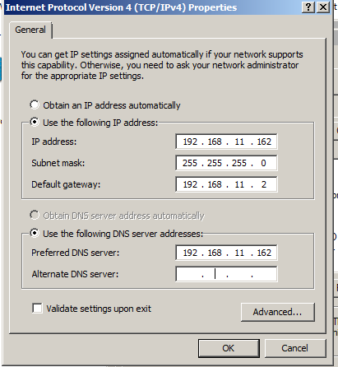
Start Menu->Administrative Tools->Server Manager->Roles->Add roles->DNS Server
it will not succeed if you not configure static ip and dns

Install Active Directory
Start Menu->Administrative Tools->Server Manager->Roles->Add roles->Active Directory Domain Services
Click Start, click Run, type dcpromo in the text box, and then click OK
Create a new domain in a new forest
FQDN of the forest root domain name(tctest.com)
Forest functional level choose Windows Server 2003
Domain functional level choose Windows Server 2003

Create Groups
Start -> Administrative Tools -> Active Directory Users and Computers
Create a new group object:
select New-> Group
Group name: Batch Process
This is list of group names
Group Number | Group Name
1 | Batch Process
2 | Service Credit Reviewer
3 | Receivables Supervisor
4 | Service Credit Specialist
5 | Receivables Technician
6 | Service Credit Data Entry Technician
7 | Financial Technician
8 | Financial Supervisor
9 | Information Technician
10 | System Administrator
11 | FACES User
12 | RIO User
13 | View Only User

Create Domain User
Start -> Administrative Tools -> Active Directory Users and Computers
Create a new user object:
select New-> User
User name: aduser
After created right click Properties
move to Member Of tab
add Groups Batch Process and Service Credit Reviewer
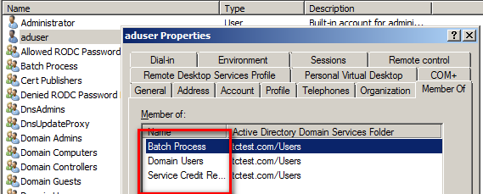

Configure Kerberos Service Principal (keytab)
Start -> Administrative Tools -> Active Directory Users and Computers
Create a new computer object:
select New-> User
User name: adtest
Password:tc0pc0AD
only check Password never expires
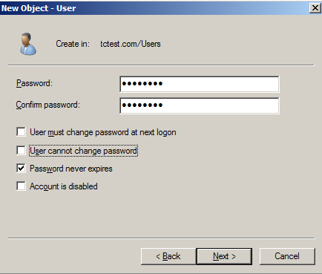
Open Command Prompt with Run as administrator
Use the setspn utility to create the Service Principal Names (SPNs).
setspn -a HTTP/rhel.tctest.com@TCTEST.COM adtest
Registering ServicePrincipalNames for CN=adtest,CN=Users,DC=tctest,DC=com
HTTP/rhel.tctest.com@TCTEST.COM
Updated object
ktpass /princ HTTP/rhel.tctest.com@TCTEST.COM /pass "tc0pc0AD" /mapuser adtest /out krb5.keytab /ptype KRB5_NT_PRINCIPAL /kvno 0 /crypto RC4-HMAC-NT
Targeting domain controller: WIN-JCQFIBC8D2I.tctest.com
Successfully mapped HTTP/rhel.tctest.com to adtest.
Password successfully set!
Key created.
Output keytab to krb5.keytab:
Keytab version: 0x502
keysize 66 HTTP/rhel.tctest.com@TCTEST.COM ptype 1 (KRB5_NT_PRINCIPAL) vno 0 ety
pe 0x17 (RC4-HMAC) keylength 16 (0x305d1bf5ba53b1cd11df0cdee21de519)

you can copy this file to JBOSS Server later and test by
running
root$kdestroy
root$kinit -k -t /home/adtest/Desktop/krb5.keytab HTTP/rhel.tctest.com@TCTEST.COM
root$klist

JBOSS Server Setup
I start with clean computer with Centos 6.4 x64 installed with normal user adtest
login as adtest

Install softwares
change to root user first by run su
install Kerberos Client
root$ yum install krb5workstation

install ldap support with Kerberos
root$ yum install openldapclients nss-pam-ldapd pam_krb5

Configure static ip and host name
root$vi /etc/sysconfig/network-scripts/ifcfg-eth0

DEVICE="eth0"
BOOTPROTO="static"
HWADDR="00:0C:29:25:6F:62"
IPV6INIT="yes"
NM_CONTROLLED="yes"
ONBOOT="yes"
IPADDR=192.168.11.18
NETMASK=255.255.255.0
NETWORK=192.168.11.2
BROADCAST=192.168.11.255
DNS1=192.168.11.162
TYPE="Ethernet"
UUID="47eccc72-e9cb-41c2-9165-e549c0880cbe"

you should configure almost same as AD Server
make sure you configure DNS as the ip of AD Server

root$ hostname rhel.tctest.com
root$ vi /etc/sysconfig/network
NETWORKING=yes
HOSTNAME=rhel.tctest.com
root$ service network restart
add AD server ip to host if you occur error when ping tctest.com
root$ vi /etc/hosts
192.168.11.162 tctest.com
192.168.11.162 WIN-JCQFIBC8D2I
192.168.11.162 WIN-JCQFIBC8D2I.tctest.com

you can verify by running root$ ping tctest.com
it should return successful message
Stop Firewall
root$ service iptables stop

Configure Kerberos Client
root$ vi /etc/krb5.conf

[logging]
default = FILE:/var/log/krb5libs.log
kdc = FILE:/var/log/krb5kdc.log
admin_server = FILE:/var/log/kadmind.log

[libdefaults]
default_realm = TCTEST.COM
dns_lookup_realm = false
dns_lookup_kdc = false
ticket_lifetime = 24h
renew_lifetime = 7d
forwardable = true

[realms]
TCTEST.COM = {
kdc = WIN-JCQFIBC8D2I.tctest.com:88
}

[domain_realm]
.TCTEST.COM = TCTEST.COM
TCTEST.COM = TCTEST.COM

make sure the time in AD Server and JBOSS Server same
Kerberos may fail when time different more than 5 minutes between client and server
see
http://blogs.msdn.com/b/asiatech/archive/2009/04/27/kerberos-authentication-failed-due-to-time-skew.aspx
you can verify by using kinit and klist command
init for domain tctest.com
root$ kinit administrator@TCTEST.COM
Password for administrator@TCTEST.COM:
list the Ticket
root$ klist
Ticket cache: FILE:/tmp/krb5cc_0
Default principal: administrator@TCTEST.COM

Valid starting Expires Service principal
09/17/13 15:55:42 09/18/13 01:55:52 krbtgt/TCTEST.COM@TCTEST.COM
renew until 09/24/13 15:55:42

Install JDK6
Please remove openjdk first
root$ rpm -qa | grep java
if found try to run command the rpm package name may change
root$rpm -e --nodeps java-1.6.0-openjdk-1.6.0.0-1.7.b09.el5
install jdk at
http://www.oracle.com/technetwork/java/javasebusiness/downloads/java-archive-downloads-javase6-419409.html#jdk-6u45-oth-JPR
if you using x64 please use jdk-6u45-linux-x64-rpm.bin
otherwise please use jdk-6u45-linux-i586-rpm.bin
I am using x64 so use jdk-6u45-linux-x64-rpm.bin
root$ chmod +x jdk-6u45-linux-x64-rpm.bin
root$ ./jdk-6u45-linux-x64-rpm.bin

Install and Configure JBOSS
download JBOSS-EAP 6.1.0 Final
http://www.jboss.org/jbossas/downloads/
You can find full configuration file under test_files
unpack and modify standalone/configuration/standalone.xml
1
replace all 127.0.0.1 to 0.0.0.0
so can connect to jboss server remotely
2
Modify Level of console handler to TRACE,so can easily find log information
<console-handler name="CONSOLE">
<level name="TRACE"/>
<formatter>
<pattern-formatter pattern="%K{level}%d{HH:mm:ss,SSS} %-5p [%c] (%t) %s%E%n"/>
</formatter>
</console-handler>
add org.jboss.security and gov.opm.scrd logger and set level to TRACE
<logger category="org.jboss.security">
<level name="TRACE"/>
</logger>
<logger category="gov.opm.scrd">
<level name="TRACE"/>
</logger>
3
add security domain host and SPNEGO
please replace the path of key tab file created in 4.5
<security-domain name="host" cache-type="default">
<authentication>
<login-module code="Kerberos" flag="required">
<module-option name="storeKey" value="true"/>
<module-option name="useKeyTab" value="true"/>
<module-option name="principal" value="HTTP/rhel.tctest.com@TCTEST.COM"/>
<module-option name="keyTab" value="/home/adtest/Desktop/krb5.keytab"/>
<module-option name="doNotPrompt" value="true"/>
<module-option name="debug" value="true"/>
</login-module>
</authentication>
</security-domain>
<security-domain name="SPNEGO" cache-type="default">
<authentication>
<login-module code="org.jboss.security.negotiation.spnego.SPNEGOLoginModule" flag="requisite">
<module-option name="password-stacking" value="useFirstPass"/>
<module-option name="serverSecurityDomain" value="host"/>
</login-module>
<login-module code="org.jboss.security.negotiation.spnego.AdvancedLdapLoginModule" flag="required">
<module-option name="password-stacking" value="useFirstPass"/>
<module-option name="bindAuthentication" value="GSSAPI"/>
<module-option name="jaasSecurityDomain" value="host"/>
<module-option name="java.naming.provider.url" value="ldap://WIN-JCQFIBC8D2I:3268"/>
<module-option name="baseCtxDN" value="CN=Users,DC=tctest,DC=com"/>
<module-option name="baseFilter" value="(userPrincipalName={0})"/>
<module-option name="roleAttributeID" value="memberOf"/>
<module-option name="roleAttributeIsDN" value="true"/>
<module-option name="roleNameAttributeID" value="cn"/>
<module-option name="recurseRoles" value="true"/>
</login-module>
</authentication>
</security-domain>

Install Ant
Download ant 1.9.2 at http://ant.apache.org/bindownload.cgi
root$ vi /etc/profile
add content
export ANT_HOME=/home/adtest/Desktop/apache-ant-1.9.2
export PATH=$PATH:$ANT_HOME/bin
You can modify ANT_HOME to match your real path for ant
reload profile
root$ source /etc/profile

Windows Client Setup
I start with clean computer with Windows7 installed

Configure static ip
ip:192.168.11.12
subnet mask:255.255.255.0
gateway:192.168.11.2
dns server:192.168.11.162

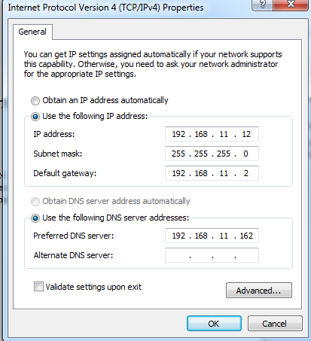

Join Domain
Start Menu->Computer right click Properties->In open System Information window click Advanced system settings
move to computer name tab->click Network ID->keep default value and input domain user name and password and domain name
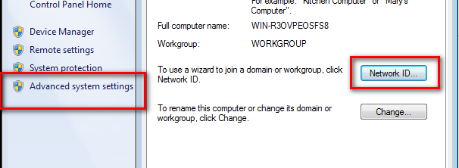
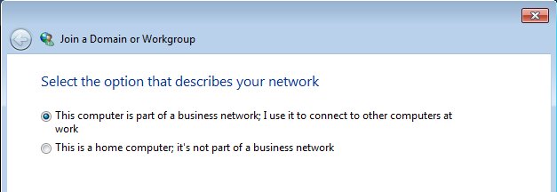
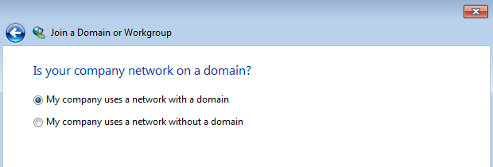
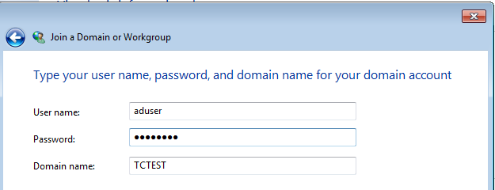
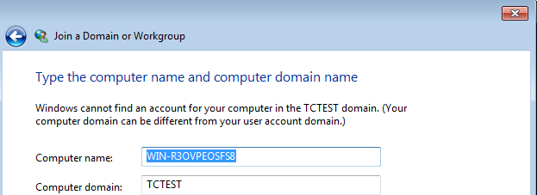
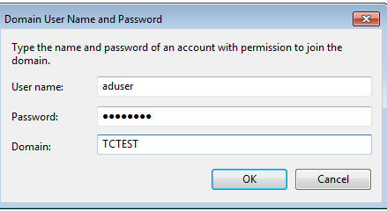
Enable domain user account and add as Administrator
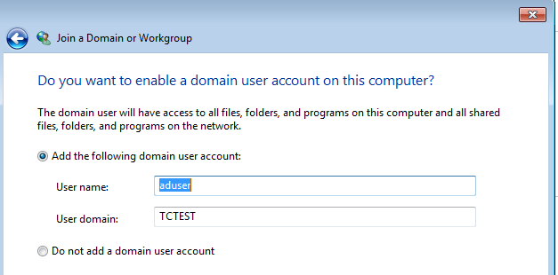
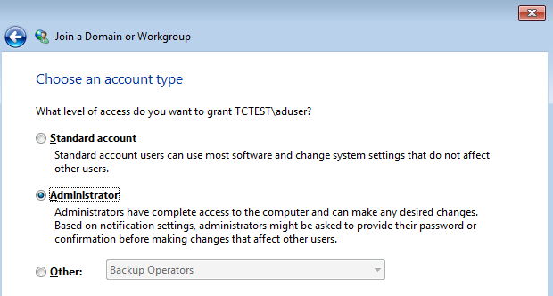

Configure host for JBOSS Server
After restart and login as Domain User aduser
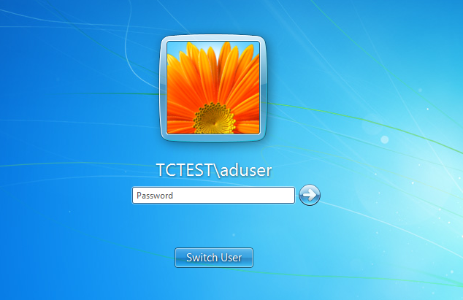

add host in C:\Windows\System32\drivers\etc\hosts
192.168.11.18 rhel.tctest.com

Configure IE
I test IE8
Tools->Internet Options
move to Security tab
click Local intranet and click Sites and click Advanced
add site http://rhel.tctest.com
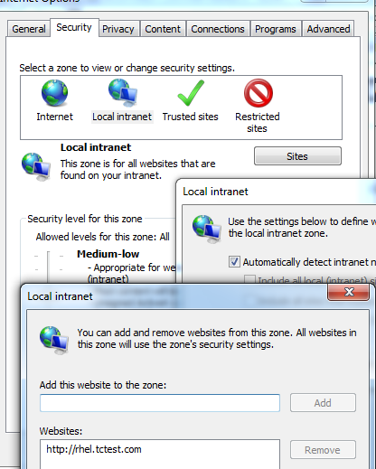

Configure Firefox
I test Firefox23
input url about:config
modify value
network.negotiate-auth.trusted-uris=http://rhel.tctest.com
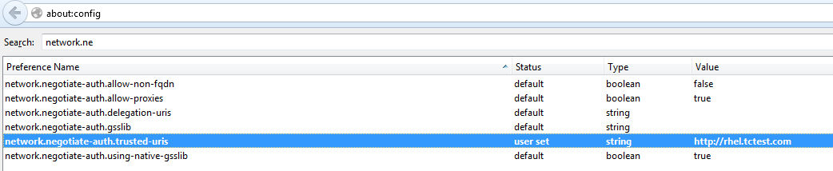

Configure Chrome
I test Chrome 29
It will use configuration by IE,so please configure IE actually

Deployment Instructions
This should be done in JBOSS Server computer
modify jboss_home in build.properties
run ant deploy

Verification
When verify by page please test under windows 7 Client,when configure jboss please test under JBOSS Server

Browser Configuration verification
below JBOSS_HOME means path where you install JBOSS EAP 6.1
copy test_files/jboss-negotiation-toolkit.war to JBOSS_HOME/standalone/deployments
move to JBOSS_HOME/bin run root$./standalone.sh
open http://rhel.tctest.com:8080/jboss-negotiation-toolkit/
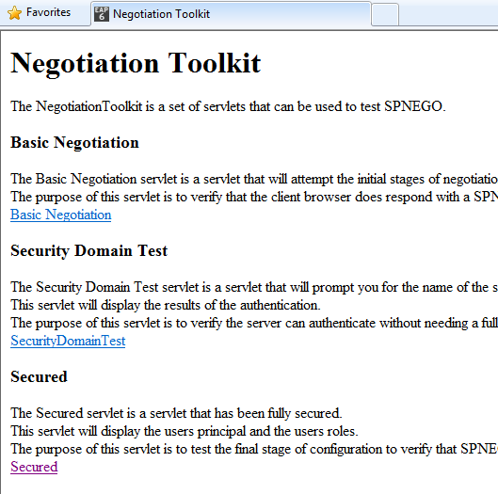
click Basic Negotiation link or open
http://rhel.tctest.com:8080/jboss-negotiation-toolkit/BasicNegotiation
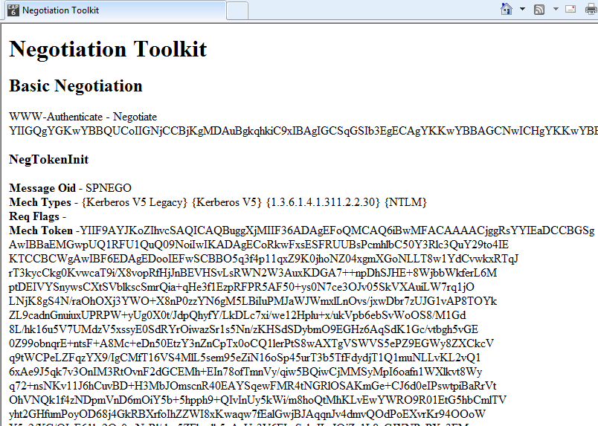

Security Domain verification
click link SecurityDomainTest or open
http://rhel.tctest.com:8080/jboss-negotiation-toolkit/SecurityDomainTest
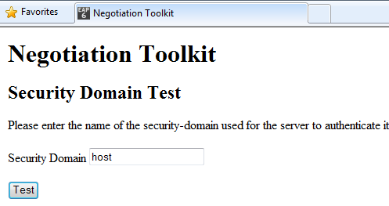
first verify host,after click Test you can find principal HTTP/rhel.tctest.com@TCTEST.COM
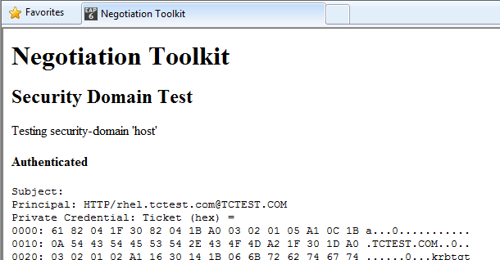
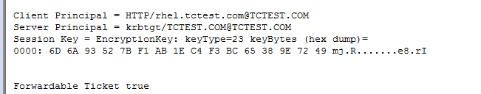

Test page verification
open http://rhel.tctest.com:8080/opm/
if you succeed you will see below page without input username or password
you can find auth type is SPNEGO,username,roles from Active Directory.
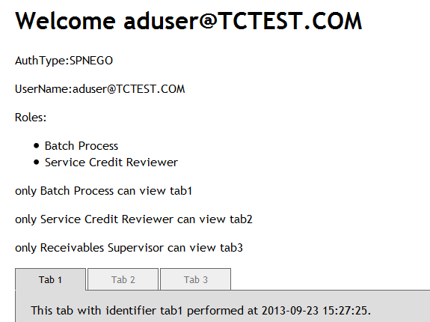

If you are Batch Process you can view tab1
If you are Service Credit Reviewer you can view tab2
If you are Recivables Supervisor you can view tab3
This the result when you are not authorized to view tab3
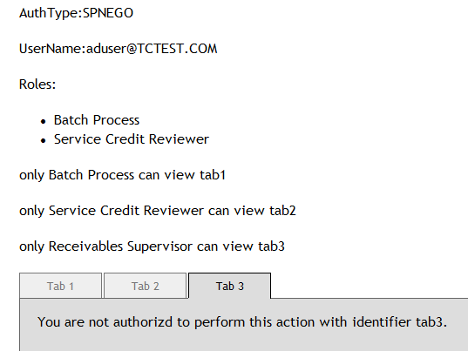

Verify Cache
Please see console result,when move between tabs first time it will output sql but second time it will read from cache,so if you change role of test user you have to restart jboss.
for example you can add Receivables Supervisor role to aduser so can view tab3 too
First click tab2
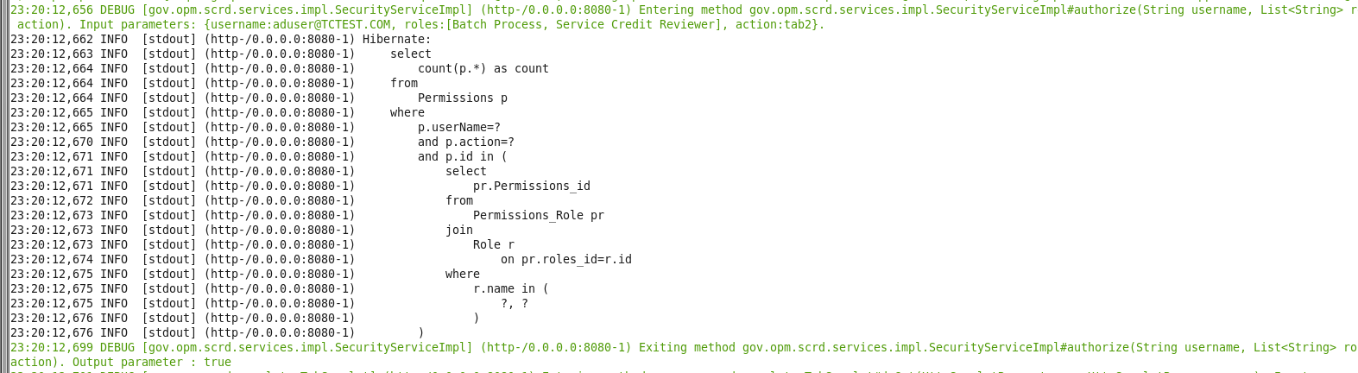
Second time click tab2

Possible issues
If you see this page please make sure current domain user is in group defined in 4.3
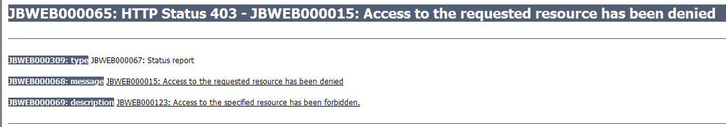

Resource Contact List
Name | Resource Email
TCSASSEMBLER

